Machrihanish Seabird Observatory (MSBO)

June Records 2016

Compiled by Eddie Maguire (Warden)

Unless stated photographs by the Warden

Photo of the month

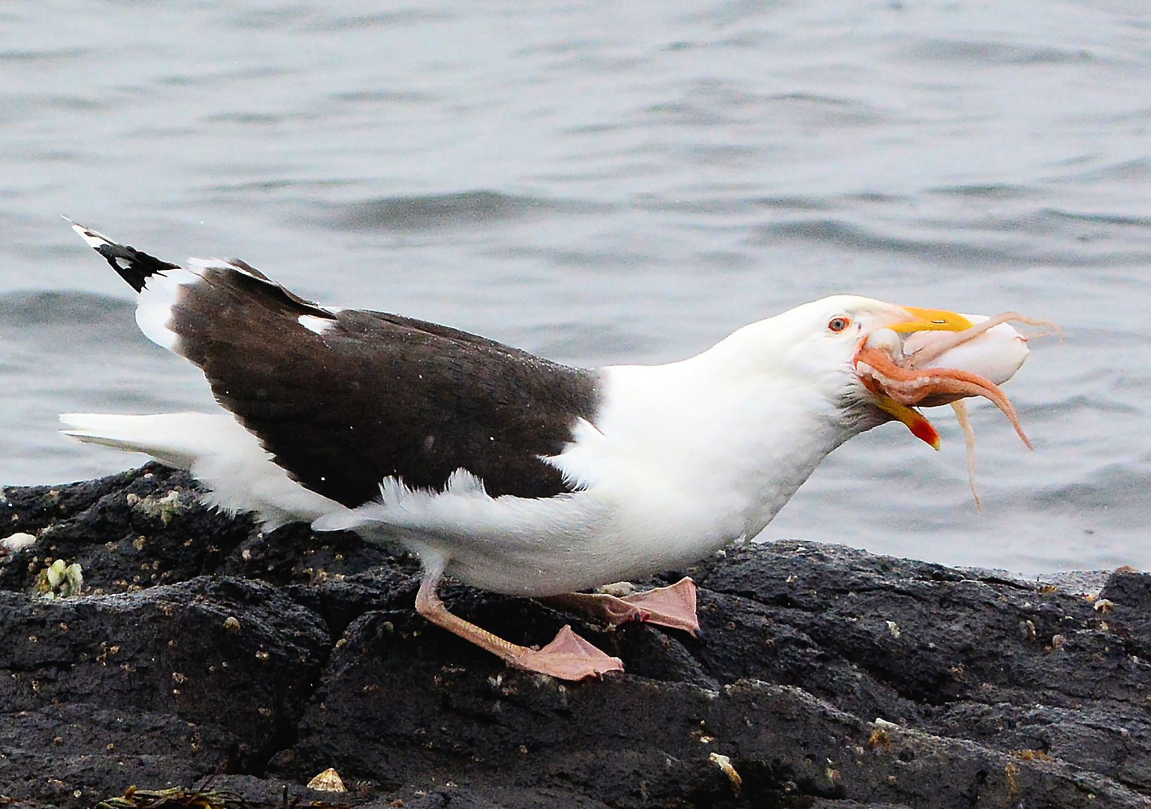
Great Black-backed Gull 16th – what a mouthful! The octopus was discarded from a lobster boat

Summary of the month...
As expected, summer fly-by’s off MSBO proved largely disappointing for most of the month with the only notable exceptions being single Teal and Tufted Duck and several records of Common Scoters including a flock of 25 males.
Whimbrel (2) occurred on a single date and Ruddy Turnstones were frequent, with up to 6 in the area and surprisingly they were still regularly roaming around the shore to 24th. At least one was still present on 28th.
This month’s report contains two short papers that include 1) details of all Goldfinch ringing recoveries in Argyll 2008-2016 (by Eddie Maguire) and 2) a review of the fortunes of breeding seabirds on the Sanda Islands (by Rab Morton).
Elsewhere, a remarkable occurrence was an Ailsa Craig-ringed Northern Gannet found dead at Campbeltown Loch. This individual was 30 year old!
The full history of this bird can be found below.

List of Selected Species

Common Shelduck
An arrival of 30 apparently adult birds on 5th was puzzling!
A newly fledged brood / 4 appeared on 14th. The May / June number of broods recorded was 6 with a total of 37 ducklings (mean brood size = 6.1).

The best ever year for Shelduck productivity at Machrihanish was 2010. The May/June number of broods recorded was 8 with a total of 75 ducklings (mean brood size = 7).

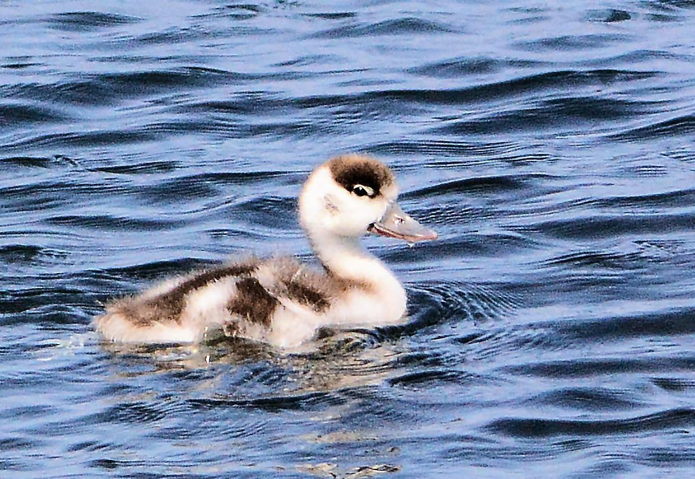
A one week old Shelduckling 18th

Teal
An adult male flew S on 9th.

Tufted Duck
An eclipse male appeared briefly on 10th then flew off S.
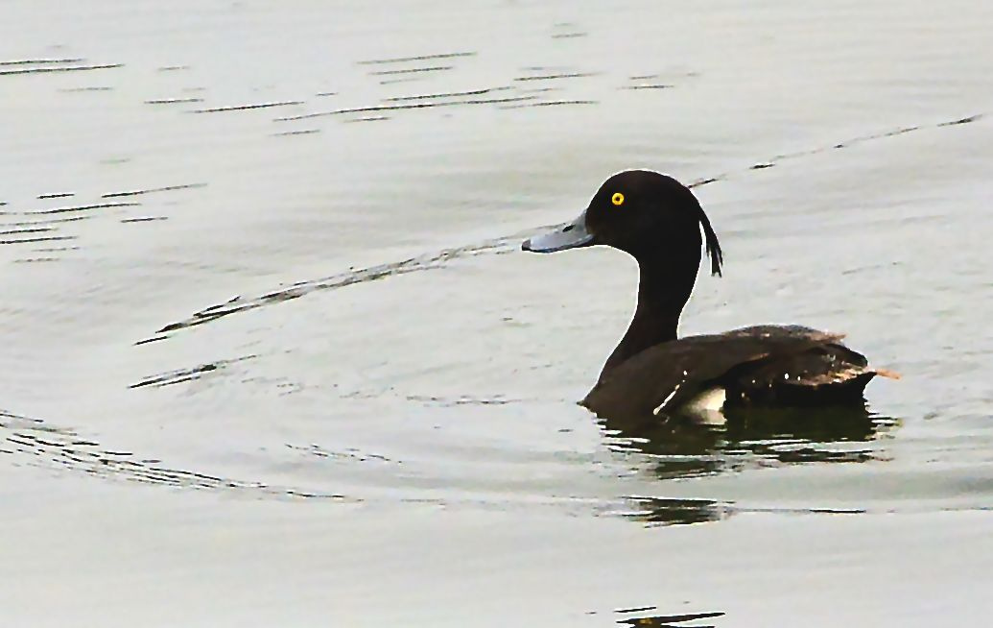
Tufted Duck – eclipse male 10th

Common Scoter
Mid-summer southerly passage of mainly adult males.
A total of 33 birds were logged between 16th (1) and 27th (6) with most (25) on 24th. Only 2 female types occurred (27th).
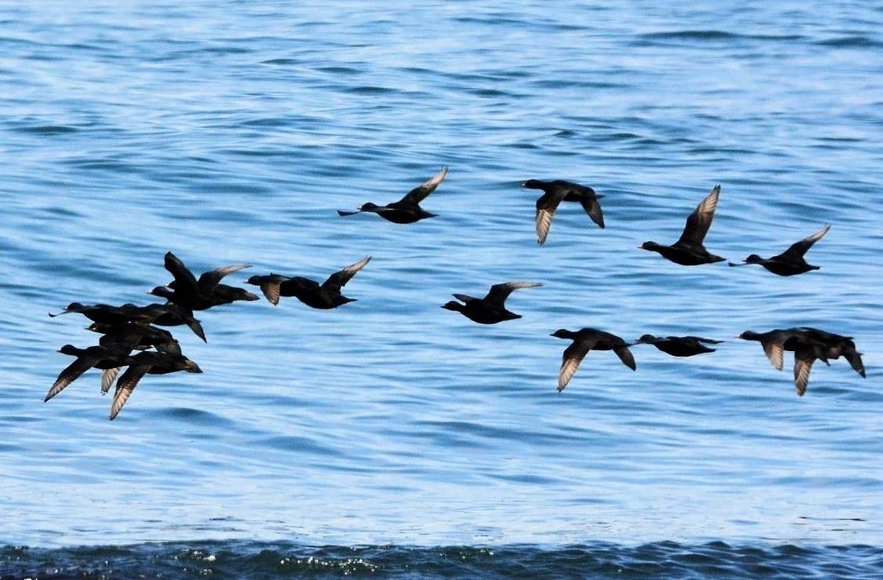
Common Scoters (adult males) on passage 24th

Common Eider
Eclipse period commenced mid-month and last adult males (singles) seen in flight before complete flightless moult period occurred on 24th and finally 27th.
Newly hatched broods appeared as follows: b/1 on 4th, b/5 and b/7 on 5th, b/6 on 13th, b/3 on 14th, b/4 on 15th, b/2 on 19th and b/2 on 26th.
The May/June number of broods recorded was 10 with a total of 35 ducklings (mean brood size = 3.5).
A look at MSBO Eider duckling productivity between MSBO and the village (1km)
during 2010-2015 reveals the following...
2015 breeding data: records revealed the lowest duckling productivity ever by MSBO. The only data logged was just three broods - b/1, b/2 and b/5 (mean brood size = 2.6). The very cold (and wet) late spring was the likely cause of this low productivity.
2014 breeding data: the May/June number of broods recorded was 8 with a total of 25 ducklings (mean brood size = 3.1).
2013 breeding data: total of 62 ducklings by the shore between MSBO and Machrihanish Watermouth on 25th (too many crèches to estimate brood sizes).
2012 breeding data: June – a total of 42 ducklings.
2010 breeding data: the best ever year for duckling productivity: 94 ducklings counted during June/July. Excluding crèche data the number of broods recorded was 16 with a total of 59 ducklings (mean brood size was 3.7).
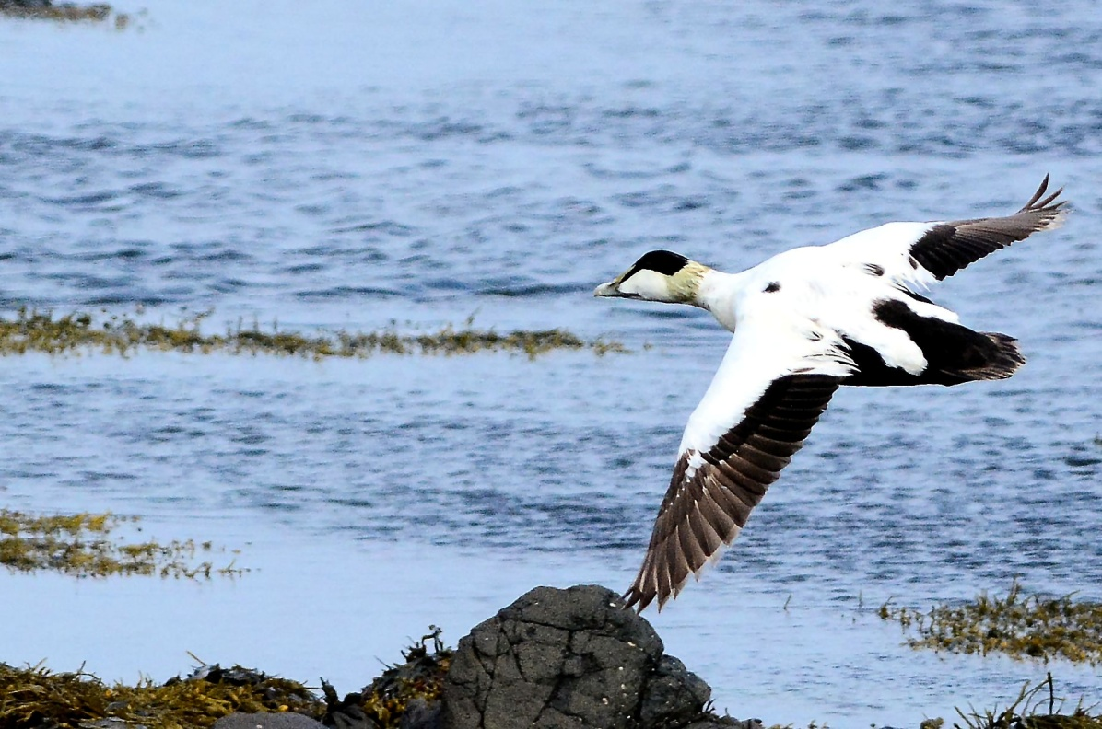
Common Eider (adult male) 27th

Northern Gannet
Ringing recovery...
Ring no. 1232330. Ringed as a nestling 28th June 1986 on Ailsa Craig, Ayrshire.
Found dead 6th June 2016 at Campbeltown Loch (per BTO / Rab Morton).
Note this bird was 30 years old!
The oldest Gannet recorded in the BTO ringing scheme to date = 37 years old. This bird was a nestling ringed on Bass Rock, Lothian on 15th July 1961 and found freshly dead on 1st December 1998 on S Ronaldsay, Orkney. The bird was 305 km from the original ringing site and its precise age was 37 years, 4 months and 16 days (per BTO).

Red-throated Diver
An adult >S on 1st. An adult >N on 13th.

Great Northern Diver
An adult was offshore on 4th.

Lapwing
One 22nd - 25th.

Dunlin
Two on 1st. One on 3rd. One on 8th. Four daily 13th-16th.

Sanderling
Five on 1st. 10 on 2nd. 25 on 3rd. 8 on 4th.

Redshank
Two adults arrived on 14th (most unusual here in midsummer).
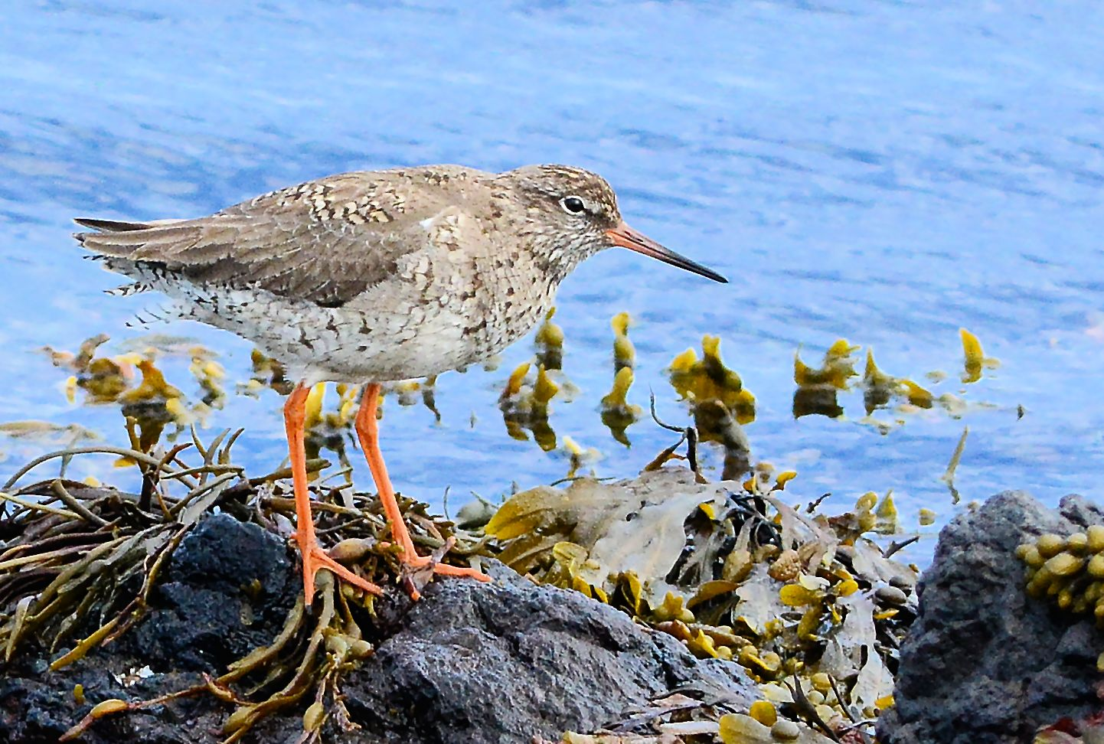
Redshank (one of two summer-plumaged adults) 14th

Ruddy Turnstone
Three on 1st. One on 4th and 5th. 10 on 6th. 3 on 8th. Six on 13th included a singing male and 5 birds were present daily 14th- 24th. One on 28th.
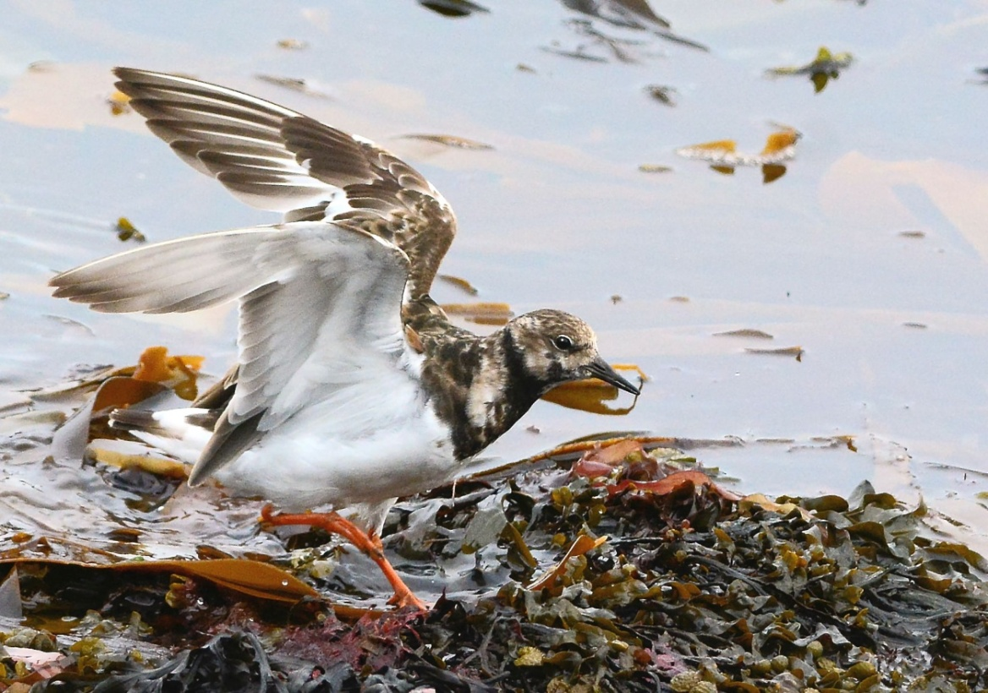
Ruddy Turnstone 21st

Whimbrel
Two on 3rd.

Sandwich Tern
Small numbers present daily: max counts 8 on 13th and 17 on 28th.
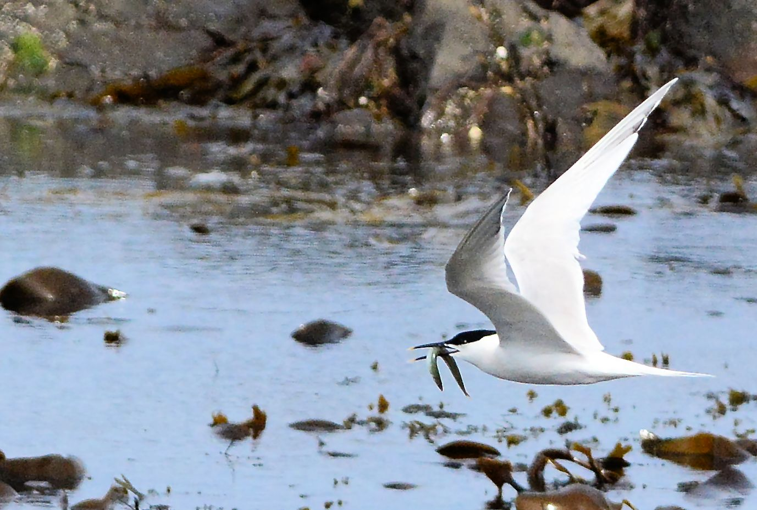
Sandwich Tern 27th
Arctic Tern
Big Scone Island off Machrihanish village: numbers at usual colony site (13) indicate that at least six pairs are possibly nesting.
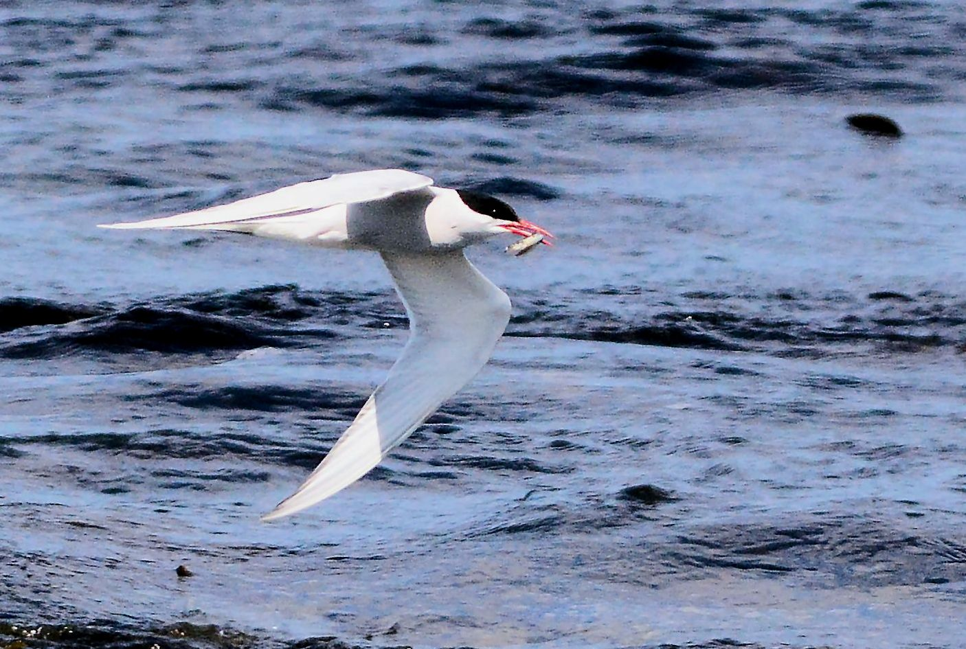
Arctic Tern on 23rd en route to nearby colony

Common Guillemot
One, a bridled morph, flew S on 17th carrying what was thought to be a small sand eel. This is the first bird seen carrying food this year and it coincides with the normal hatching period at, for example, the Sanda Islands colony (3rd week in June / Rab Morton pers. comm.). Birds were noted carrying food S daily from 18th.
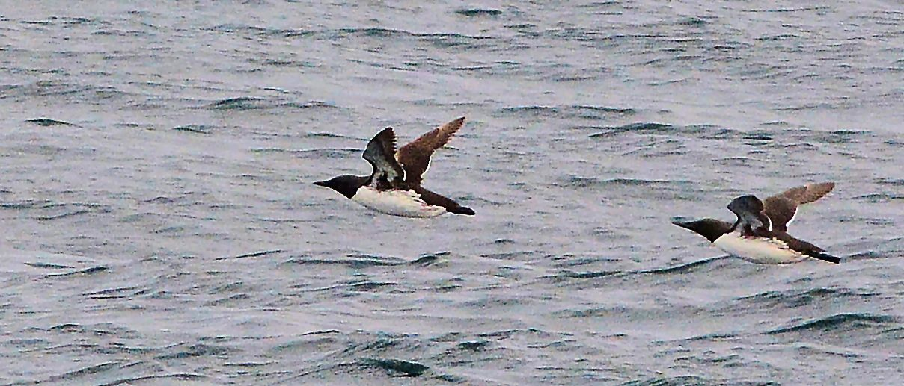
Common Guillemots 25th

Puffin
One flew S with Common Guillemots on 25th.
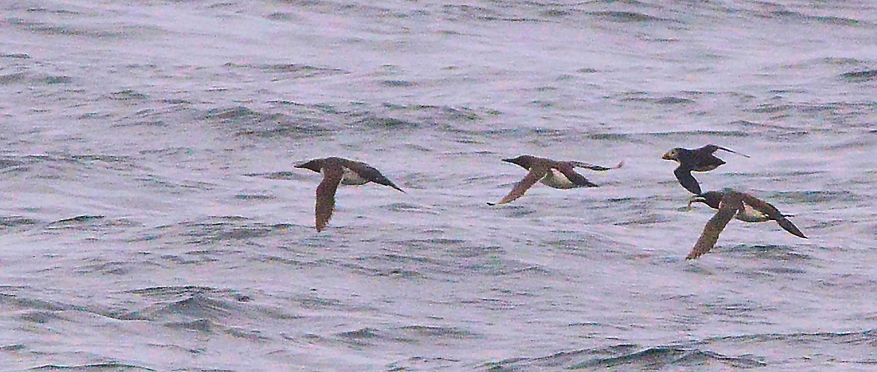
Puffin travelling S with Guillemots off MSBO 25th – note Guillemot (right) carrying sand eel

Stonechat
Four pairs were found between MSBO and Ballygroggan Farm (1 km) on 16th.

Starling
Numbers of juveniles built up slowly to 30 on 8th and by 19th at least 55 were in the area (foraging for kelp fly maggots)

Records from around Kintyre during June

Northern Fulmar
Muasdale (N of Glenbar): one ashore 7th and 10th (Bob Middleton).

Corn Crake
One calling on 1st in field opposite Machrihanish Airbase guardroom (MACC: ex RAF / Defence Estates). Apparently this bird has been present since at least mid-May (Davie McPherson / Stuart McGougan pers. comm.).

Herring Gull
Campbeltown: dwelling house roof-nesting. Broods of 3 were noted at 18 and 21 Calton Avenue, 67-69 Davaar Avenue and Albyn Avenue. Broods were also seen / heard on rooftops at Longrow South, Argyll Street and Hall St.
The majority are nesting behind chimney breasts / difficult to determine just how many pairs are involved.

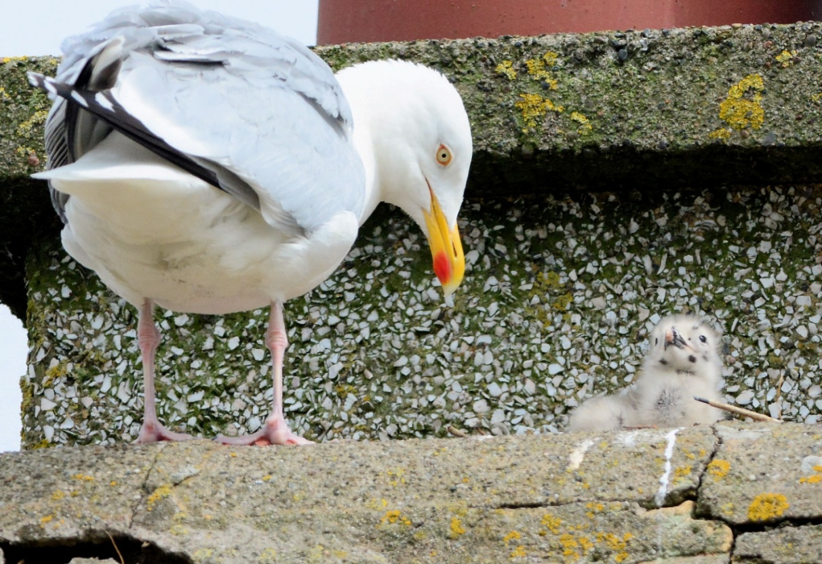
Herring Gull and chick on a Campbeltown rooftop – one of a brood of 3 at 21 Calton Avenue 15th

Goldfinches on the Move
An Update – June 2016

By Eddie Maguire

Prior to 2007 there was no information on movements of Goldfinches in Argyll (ap Rheinallt, T., et al 2007; Birds of Argyll).
Including a bird that was ringed at Campbeltown and controlled in Belgium (Argyll Bird Report 2013) the information presented here, is, as far as I am aware, the complete history of all Goldfinch movements to / from Argyll.
Information on three ringed birds controlled recently follows...

Z707030: ringed 16th January 2016 at Petre Crescent, Rishton, Lancashire.
Controlled at MSBO 11th April 2016 (aged / sexed as first-winter female).

Z884824: ringed 17th March 2016 at Cross Lane Head, Bridgnorth, Shropshire.
Controlled at MSBO 11th April 2016 (aged / sexed as adult male).

Z951418: ringed 25th February 2016 at Northorpe Fen, Lincolnshire.
Controlled at MSBO 9th April 2016 (aged / sexed as first-winter male).

There are another 7 previous controls of this species at MSBO. Four were ringed in winter in England (Cheshire, Shropshire, Suffolk and Yorkshire). The other controls involved birds ringed at Magee Island (Co. Antrim), Strathclyde Country Park and a Welsh-ringed bird from Bardsay Island B.O. (see Goldfinches on the Move: The Eider, Number 100, June 2012).

Only one of hundreds of Goldfinches ringed at MSBO has been reported elsewhere and this was controlled in England (Shropshire).
This important Argyll data adds weight to analysis of BTO ringing recoveries that many Scottish Goldfinches travel SE to winter in England.

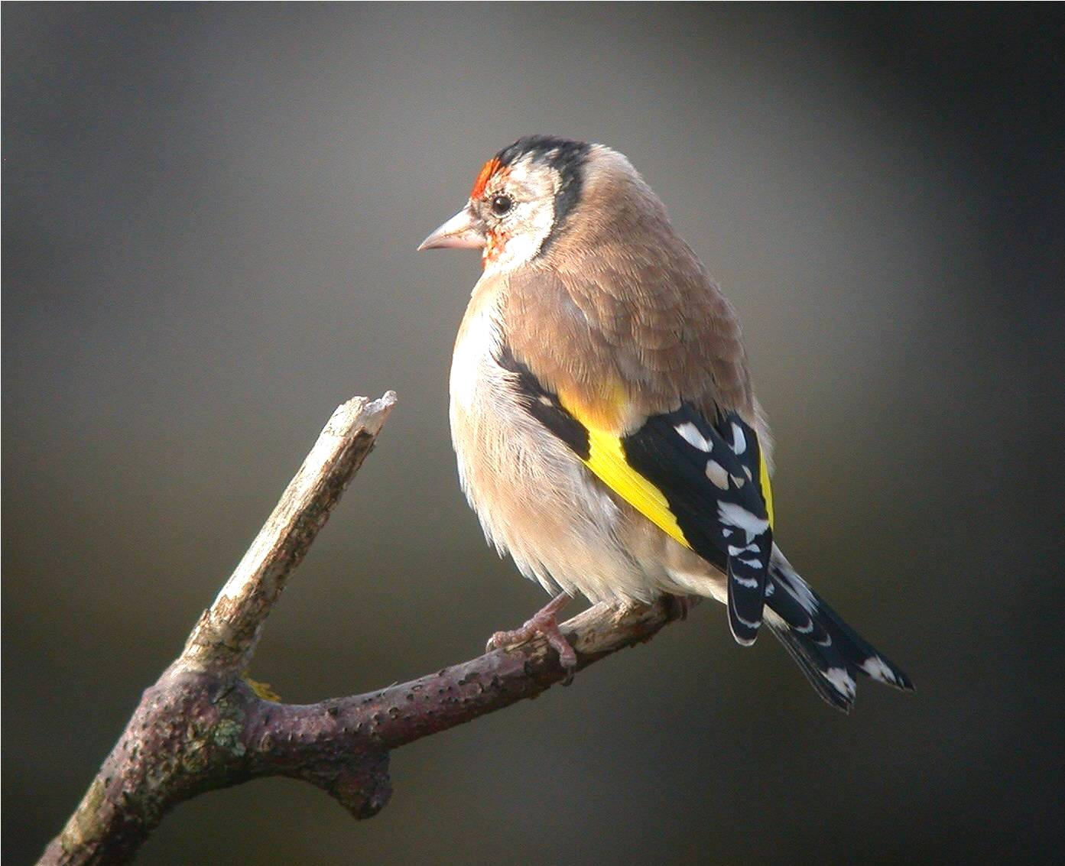

The following map reveals the ringing locations of all Goldfinches controlled (10) / recovered (1) at MSBO during 2009-2016.

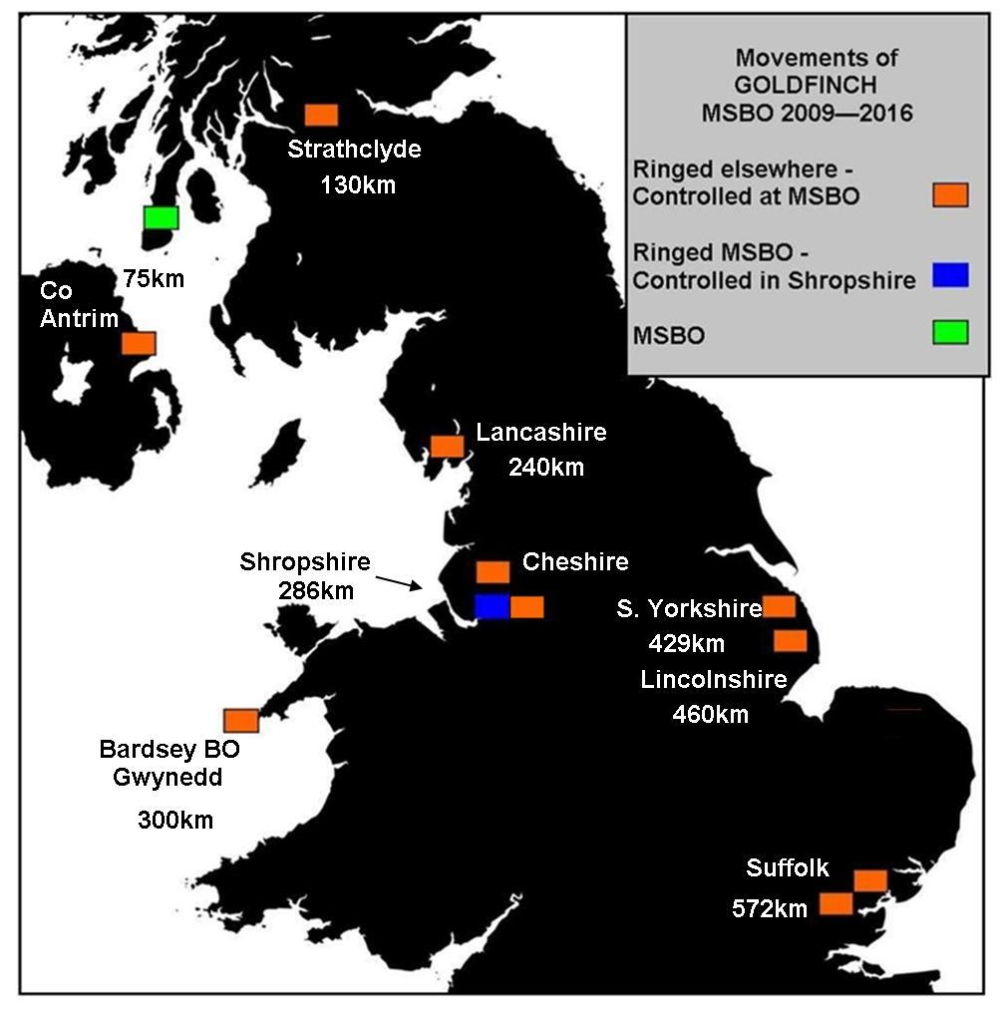.

The Breeding Birds of Sanda Island

&
Smaller Satellite Islands
Sheep and Glunimore

By Rab Morton

Introduction...
On 6th June 2016, a boat trip was organized around the Sanda Islands to assess the breeding populations of seabirds.
Many digital photographs of the colonies were taken and all known nesting sites were scrutinised carefully with binoculars.

Results...
The island counts are produced in Table1 below and all results of these (with a few exceptions) largely equate to a survey carried out in 2010 (see Table 2).

Notes...
AOT= Apparently Occupied Territory
AON= Apparently Occupied Nest
Northern Fulmar, Manx Shearwater and Storm Petrel were not included in this survey and the * Black Guillemot count was undertaken during April 2016.

Table 1.
Counts / estimates for the whole island group 6th June 2016.

Species | Sanda | Sheep | Glunimore
Cormorant | 0 | 0 | 18 AON
Shag | 15 AOT | 15 AOT | 0
Common Gull | 25-35 AOT | 0 | 0
Lesser Black-backed Gull | 2 AOT | 3 AOT | 0
Herring Gull | c. 180 AOT | c. 150 AOT | 3 AOT
Great Black-backed Gull | 4 AOT | 10 AOT | 6 AOT
Black-legged Kittiwake | 0 | 0 | 30-50 AON
Common Guillemot | 0 | 0 | c. 4000 birds
Razorbill | 80 birds | 50 birds | c. 300 birds
* Black Guillemot | 128 birds | 0 | 0
Puffin | 80 birds | 70 birds | 30 birds

Table 2.
Counts submitted to Joint Nature Conservatory Councils Seabird Monitoring Register during 2010. Note that the species totals are for the whole island group.

Species | Totals....  Sanda, Sheep & Glunimore Islands
Northern Fulmar | 132 pairs
Manx Shearwater | 300 pairs
Storm Petrel | 200 pairs
Cormorant | 17 pairs
Shag | 354 pairs
Common Gull | 60 pairs
Lesser Black-backed Gull | 9 pairs
Herring Gull | 210 pairs
Great Black-backed Gull | 21 pairs
Black-legged Kittiwake | 36 pairs
Common Guillemot | 5000 birds
Razorbill | 4000 birds
Black Guillemot | 180 birds
Puffin | 160 birds

Discussion...
Fulmars were not counted as birds present on ledges do not necessarily represent an active nest site. This was first noted during 2006 and on the last full count (2010).
Both Manx Shearwater and Storm Petrel nest underground and are monitored by occupied nest sites; therefore, no counts were possible.
Herring and Great Black-backed Gulls appear to be doing well; however, productivity levels are not available.
Lesser Black-backed Gull has declined although there were never large numbers breeding.
Common Gull declined to single figures but now show a significant increase; yet again, productivity levels are not available.

Predation of seabirds...
During 2010, it was discovered that there was Mink killing large numbers of seabirds on Sanda and Sheep Islands, especially Razorbills. The two main colonies on these islands are now deserted.
Interestingly, in 2013 / 2014, RSPB researchers noted that Black Guillemots were no longer employing traditional boulder field nest sites, and instead, were nesting on cliffs.
Was this change in nest site selection from boulder field to cliff conceivably in response to Mink predation? It would seem so.
The elevated adjustment in nest site selection was also noted in summer 2015: no Black Guillemots appeared to be frequenting the traditional boulder field shore sites on the NW side of Sanda that incidentally this species had occupied so diligently as a breeding site for over 30 years in the past. Birds were noted flying up to what were obviously cliff nest sites. This very recent behaviour in change to nest site selection was possibly in response to persistent predation of clutches / chicks and probably adults too at boulder field ground level nest sites (Rab Morton personal observations).

Conclusion...
Unlike Sanda and Sheep Islands, the numbers of breeding seabirds on Glunimore do not appear to have been affected by the recent, extremely worrying, incursion by Mink.
The Shag colony on Sanda Island and the Razorbill colonies on both Sanda and Sheep Islands appear to have suffered most.
Species not surveyed from the boat-based June 2016 partial survey included Manx Shearwater, Storm Petrel and Puffin: all are nesting underground either in burrows or boulder fields and all must surely be extremely vulnerable to predation by Mink, now, and in the future.
Surely the time has arrived for Scottish wildlife agencies to become involved and instigate a programme of Mink eradication on these islands that have contributed so much important information to our knowledge of breeding populations and movements of ringed seabirds in S Argyll for almost 40 years?
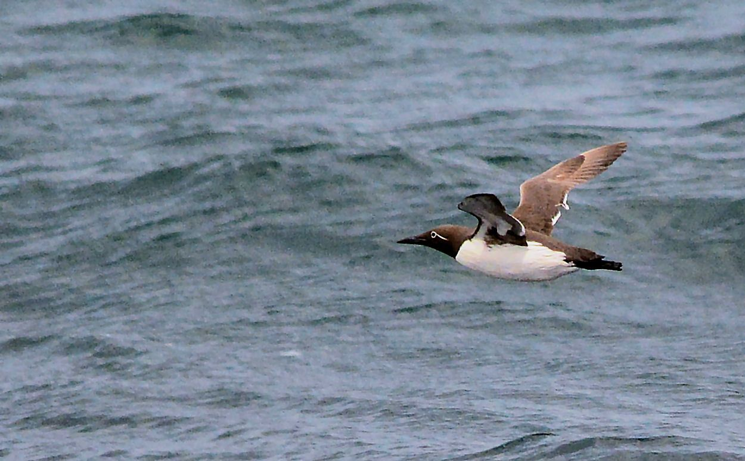
Common Guillemot (bridled morph)

SOME MORE PHOTOS

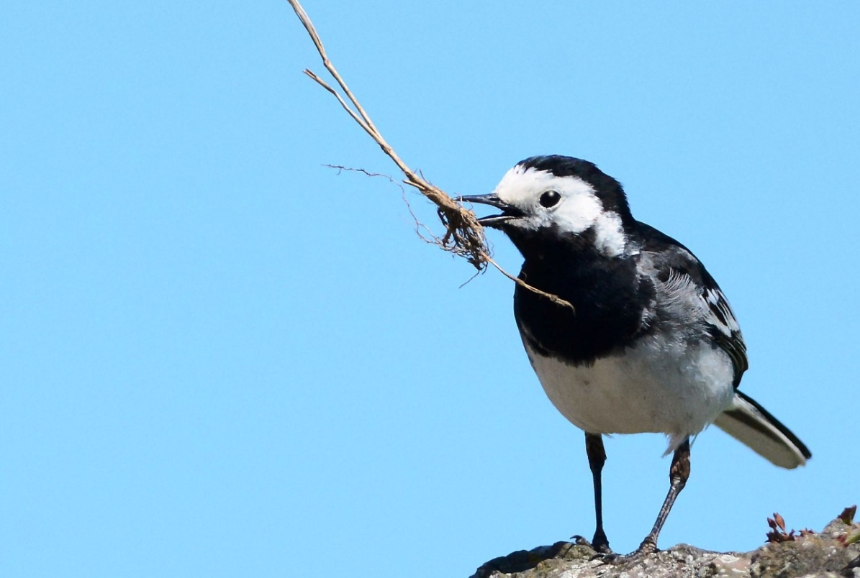
Pied Wagtail - nest building male MSBO 1st

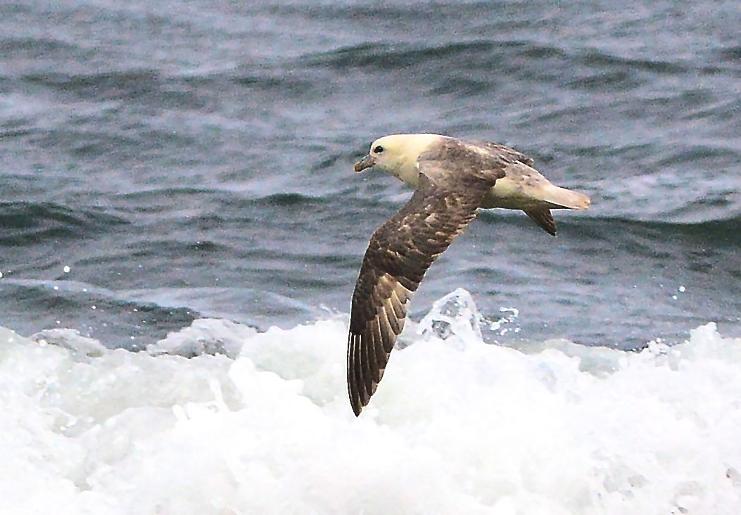
Northern Fulmar MSBO 10th
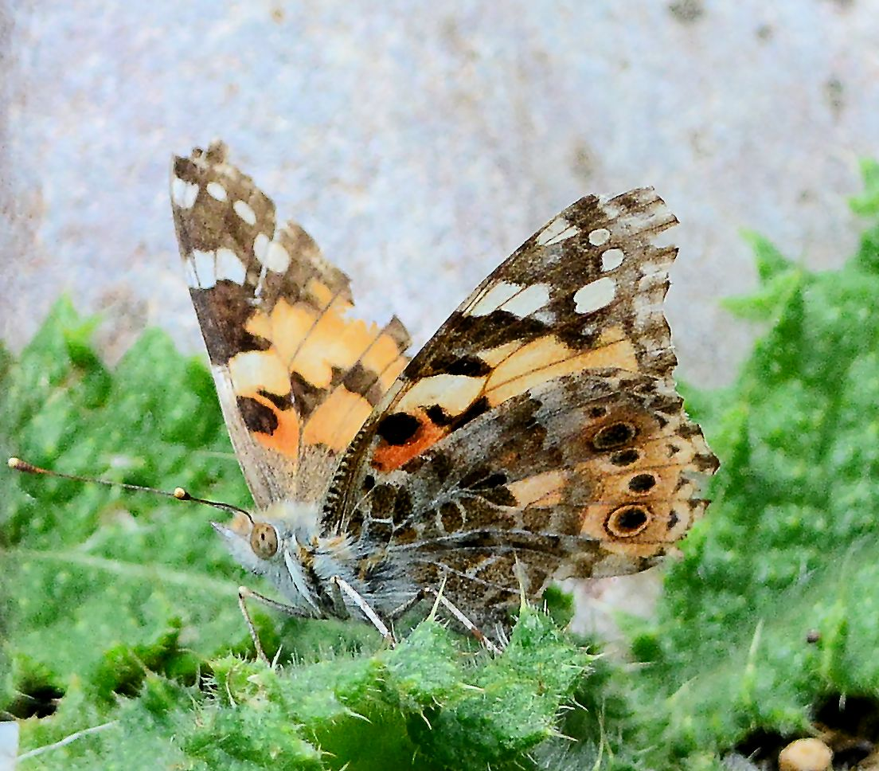
An impressive period for remarkable numbers of Painted Lady Butterflies

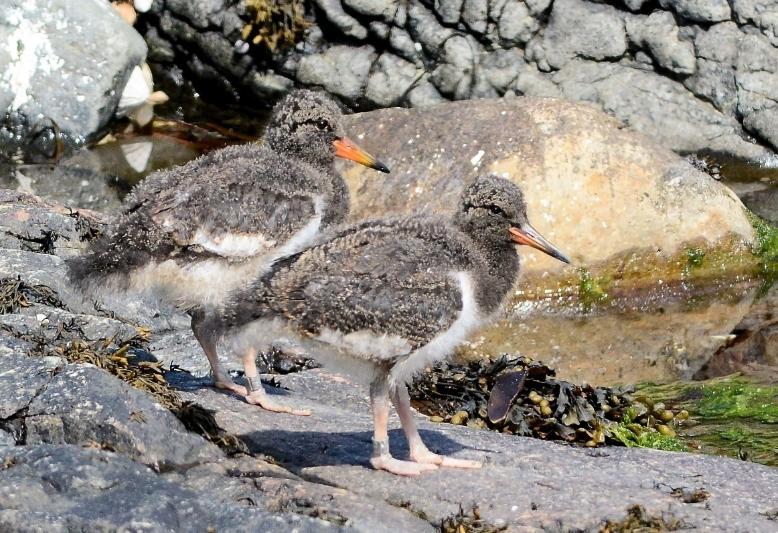
Oystercatcher siblings MSBO 24th

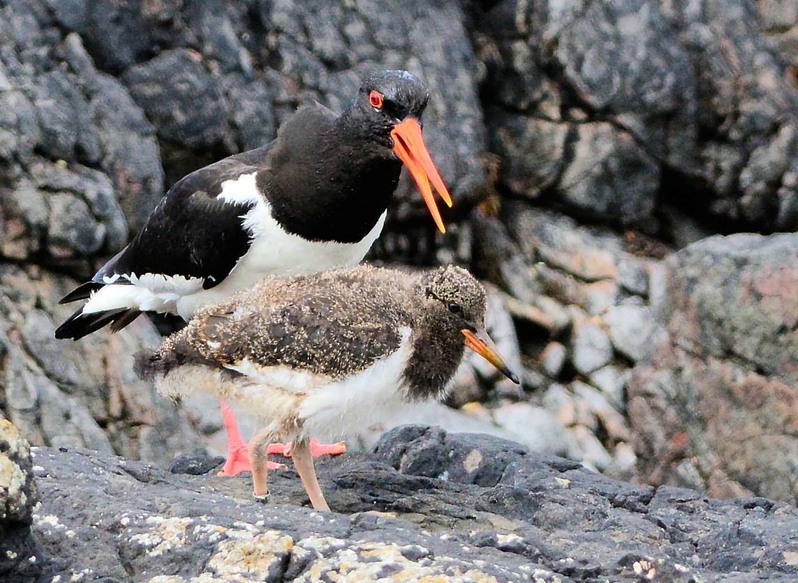
Oystercatchers 25th
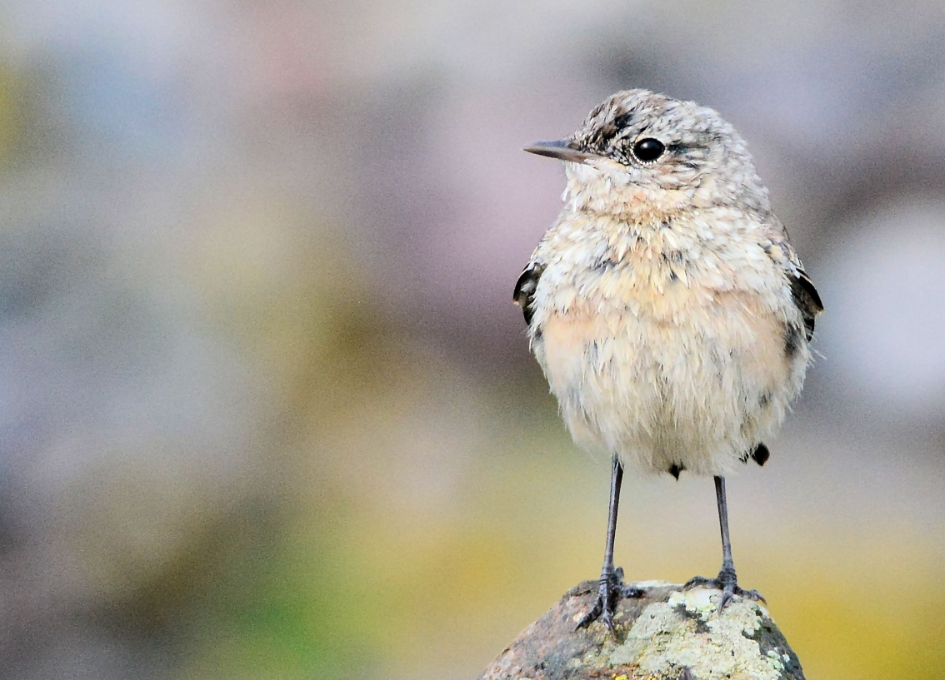
Northern Wheatear (juvenile) MSBO 28th

